**Hiran Minar Photo Frame Art**

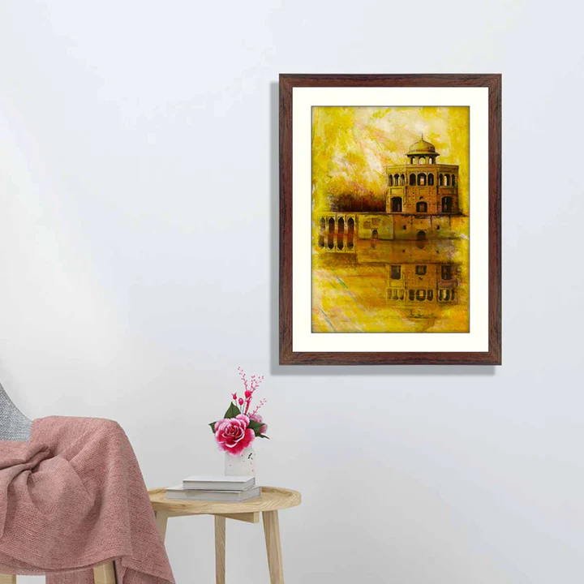Hiran Minar, located near Sheikhupura, Pakistan, is a stunning Mughal-era monument surrounded by an aura of history and tranquillity. Built by Emperor Jahangir in memory of his beloved pet antelope, this unique structure reflects the Mughal affinity for nature and architecture. At sunset, the octagonal minaret glows warmly, casting its reflection on the shimmering waters of the surrounding tank. The nearby baradari (pavilion) adds to the serene ambiance, while the chirping of birds accentuates the peaceful environment. Hiran Minar stands as a testament to love, art, and the timeless legacy of Mughal ingenuity.